Taylor Johnson
TEL 311
Professor McLendon
4 December, 2014
Signature Assignment For TEL 311: Instruction Management in an Inclusive Classroom

The Educational Philosophy of Taylor Johnson
I believe that students are unique individuals who deserve an engaging learning experience that helps prepare them for their futures. W. B. Yeats accurately described this style of teaching when he declared, “Education is not the filling of a pail, but the lighting of a fire.” Therefore, I desire to facilitate a student oriented, student driven classroom which ignites the student’s passion for knowledge. Through my own educational experience, I discovered that I always learned more and retain that knowledge better when I was personally invested in what I was learning. By incorporating the students own interests into my classroom I would hopefully stimulate a fun, dynamic and purposeful learning experience, driven by the students desire to learn. Knowledge is power. Once students are invested in their own learning experience, there is no limit to what they are capable of achieving.
I believe that students deserve a class that teaches useful and necessary skills that they can apply in real life situations. This includes critical thinking skills that they can utilize to solve problems and create solutions to everyday obstacles. Communication skills are a vital area for students to develop because of their importance in the work field. By encouraging communication skill in my classroom, students will begin to analyze methods of communication and implement the most effective, appropriate, means of communication. By practicing in the classroom, they will build an understanding of their target audience, the resources available to them and then design their communication accordingly. Going hand in hand with this is the idea of collaboration. I have discovered through my experiences as a camp counselor, a student, and a student-teacher, that working effectively in a group setting is an essential ability students need to develop in order to be successful in their lives. Whether it’s in a work environment or just a casual setting, building those team player abilities can help produce well rounded and considerate individuals. By allowing students to focus on these skills in the safety of a high school setting, they are provided the opportunity to try something new, take a risk, and improve in ways they never thought possible.
I believe that all students are intelligent individuals who should all have the opportunity to succeed. Students have a variety of interests, a variety of learning methods, and a variety of skills that can be used to further their academic achievements. Therefore, I plan to offer as many resources to my students as I possibly can. For example, I would like to provide a physical text, an online text, an audio recording and a video recording so that students of all learning styles can best understand the material. I also plan to be flexible in how students present their evidence of mastery over the material. Perhaps one student decides to paint a picture about what she has learned and then provide a short argument of how her artwork demonstrates that. Perhaps another students will create a website demonstrating his mastery over the subject material. No two students are exactly alike and I believe that they will gather a greater understanding of the material if we allow them to learn in their area of strength.
I believe that students deserve a chance to learn in an environment where they can make mistakes and grow. Therefore, I plan to implement a Positive Discipline Strategy which provides researched based procedures to increase positive behaviors in students. This would provide the student with strategies to help regulate their behavior and an environment that is conducive to the learning process.
I believe that as a teacher, I will provide students the opportunities to grow into principled members of the community who will not only succeed in life but who will also make an enormous impact on the entire world. Students have the potential to do amazing things and as their teacher, I want to see that happen. My entire life I have always desired to be a teacher because I see the potential students have and I want to see them achieve their wildest dreams.

Course Syllabus
Sophomore English
Miss Taylor Johnson
Contact Information:
Phone: (714) 791-8836
Email: taylor.johnson246@gmail.com
Course Page: http://missjohnsonssophomoreenglish.weebly.com
Course Description
This English course presents a literary exploration of World Literature from the very earliest of literary texts to some more modern ones. Through the specified literature for this class, students will improve their reading comprehension, their writing ability including rhetorical and persuasive essays, style, structure and fluidity, their analyzing skills, and their research abilities such as using outside sources.
Course Objectives
- Write an expository essay with structure, argument, style, and support.
- Write a persuasive essay with structure, argument, style, and support.
- Read and comprehend literature on the tenth grade reading level.
- Develop skills to utilize technology for instructional and workplace environments.
Texts and Required Supplies
- Elements of Literature 10th Grade Edition
- Composition Notebook
- Folder
- Paper
- Pencils and Pens
School Rules
All school rules will be upheld in this classroom. For further details not found in this syllabus please refer to the school rules handbook.

The Start of Class
Class will begin as soon as the bell rings. Please be in the class and in your seat when the bell rings. When you come in your bell work will be on the board. Please complete the bell work as quietly as possible in your journals. We will discuss them after a few minutes. The class agenda and goals will be posted on the board so that you are aware of what we will be accomplishing in class.

The End of Class
I will try to give you time to pack up before the bell rings. Please do not begin packing up until I have dismissed you. Please return all materials to their proper place and leave the classroom as neat and tidy as possible.
Transition between Activities
Class time is valuable and limited. Please transition between assignment s and activities as quickly and quietly as you can. All materials that are no longer needed should be returned to their proper places and the new materials acquired. Please respect our classroom time and I will respect your time.

Communicate with Parents
Parents are advised to also check our class website for updates and assignments. However, if parents need more direct contact they are free to email me or call me at any time. I will respond as promptly as I can. Please allow at least 24 hours during the school week and 48 hours over the weekend.

Composition Notebook
The composition notebook used in this class will be a major component that contains a great number of the daily, classroom assignments. This is where students will complete many assignments including bellworks, class assignments, homework assignments and many more. This is required for every class period and must be purchased either from a school supply store or from me.
Grading Plan
A 100-90% B 89-80% C 79-70% D 69-60% F 50% or less
Grading done by semester. Points will be added and divided by the total amount of points that semester to find the percentage earned and the associated grade. Although there are no planned extra-credit opportunities, they will be provided throughout the semester. Please take advantage of these rare opportunities. Assignments will be weighted as follows:

Tests 30%
Projects 30%
Homework 30%
Participation 10%
Basic Expectations
- Respect those around you.
- Participate in all assignments and discussions.
- Come to class completely prepared.
Late Work
If for some reason you do not complete the assignments by the time indicated, you will have one week from the original due date to turn in the assignment. This assignment will be worth exactly one half of the original worth. Once that one week has passed, the assignment will no longer be accepted. In addition, I allow once Homework Pass each semester. A Homework Pass allows you as a student to turn in the assignment one day after the original due date for full credit. This Homework pass may not be used on the essays or final projects. The Homework Pass is designed for students who really do forget to do their homework or print it out. This is the one pass to allow for simple mistakes or forgetfulness. However, you can also use this one Homework Pass very wisely for when you might need extra time to complete an assignment. If you plan to use your Homework Pass, you need to speak to me before class on the day that it is due and then write in big, bold letters Homework Pass on the top of the assignment.
Attendance and Tardy Policy:
Attendance to class every day is necessary to do well in this class. In addition, please arrive on time, prepared with all materials and homework. Please respect my teaching time in the classroom and I will respect your time out of the classroom. If you are absent, it is your responsibility to check the Schedule and Assignment folder in the classroom or the corresponding page on the class website to complete everything covered that day. You have exactly one week from the class day you return to class to complete the assignment. Assignments submitted after this week will not be accepted.
Homework
Homework and assignments will be collected at the very beginning of class in a basket. Once we are discussing the bellwork, you will no longer be able to submit your homework. No exceptions. This homework will either be passed back at the end of the class with a stamp to show you completed it on time or it will be returned at the beginning of your next class with my comments.
Individual Preferences
If you have a need or special accommodation, I am more than willing to comply and assist you in any way I can. Please speak to me privately about this either before or after class, or send me an email.
Contacting Me
Please feel free to contact me at any time. If you email me, please include your period and full name in the subject line. If you call me, please leave your name, period and number so that I can call you back. Please allow at least twenty-four hours for a response during the school week and forty-eight hours over the weekend.
Electronic Policy
Please do not use electronic devices in class unless I have given you specific permission to use them. We will be utilizing electronics and technology frequently in class and you will have ample time to explore and experiment with technology. Please respect my instruction and leave all electronics turned off and stowed in your backpacks in the back of the class. If you are caught using your electronic device, such as a cellphone, inappropriately or without permission, this device will be taken away and given to the front office.
Academic Integrity and Plagiarism
Academic integrity is of the utmost importance. Please sources and resources when doing homework, research and essays. As a rule, if you did not think of it yourself then you need to give credit to the source. If you are caught in academic dishonesty or plagiarism, whether intentional or unintentional, the consequences are a failure for the assignment, an email to all the teacher in the school regarding the academic dishonesty, and a mark on your permanent record. When in doubt, please ask. You will be required to submit all essays and large written assignments to Turnitin.com. Academic dishonesty includes copy the work of others. Collaboration between students is always welcome but collaboration includes work and participation from all students. It does not include copying answers either word for word or paraphrasing from another’s completed homework.
Food and Drink
Food and drink is allowed in class. However, I ask that you respect both my area and yours and clean up after yourselves. A trash can will be provided in the room where all waste can be disposed. If this becomes too much of a distraction, I reserve the right to restrict food and drink from my classroom.
Disciplinary Actions
If disciplinary actions are necessary at any time, I will first issue an explicit warning to the student. If the inappropriate action continues then the student will be asked to stay after class for a quick conference. If the problems still continues then one of the following actions will be taken: lunch detention, a call home to a parent, a parent conference, and a visit to the principal’s office. For more serious offenses, I reserve the right to skip the first two actions and automatically send the student to the office.
I Am Here For You
As your teacher, my primary goal is not only to teach you how to read and write but I am also here to support you through your high school experience. If at any time you need help or assistance, please come to me. I will either provide you with the support you need or send you to the appropriate resource.

Classroom Layout
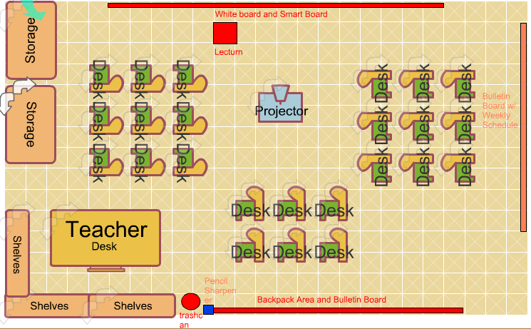
This would be my ideal classroom layout. All of the desks would be facing each other so that discussion could be stimulated. However, the students also have easy viewing access to the projector screen. The backpack area is the place where students would hang their backpacks so that they are not distracting during class time. Students will be allowed to access their bags before class, after class and during work time. The bulletin board on the right of the room would have the weekly schedule for students. Rather than a bulletin board it could also be another white board, whichever is easier to procure. My desk is located so that I can observe the entire classroom during any activity. The book shelves around my desk would be off limit to students. The storage containers would be the location for student supplies like books, textbooks, whiteboards and anything else they need for class. I will utilize the bulletin board in the back of the classroom for posters and information about writing, reading etc.

References
Educational ideas gathered from personal experience in high school attending Ocean View High School.

